
School of Future Tech
CASE STUDY

JWT Security Laboratory

Rima Maji (150096725215)
B.Tech in CSE
ITM Skills University
Data Structures and Algorithms Using C++

Index

- Introduction to the Case Study
- Problem Statement / Case Background (Abstract)
- Problem Statement / Case Study Design
- Methods & Technologies Applied in the Case Study
- Case Study Implementation Details and Snapshots
- Case Study Results and Conclusion
- References

1. Introduction to the Case Study
JSON Web Tokens (JWT) are widely used in modern web applications for authentication and secure information exchange between systems. JWT provides a compact and self-contained way of transmitting information between parties as a JSON object. Since JWTs are commonly used in authentication and authorization systems, understanding their structure and security implications is important for developers.
This case study focuses on designing and implementing a JWT Security Laboratory using React.js. The application provides an interactive environment where users can generate JWT-like tokens, decode their contents, verify token integrity, and simulate common JWT security vulnerabilities.
The project demonstrates how JWTs are structured into Header, Payload, and Signature sections while also highlighting the importance of secure token validation practices.

2. Problem Statement / Case Background (Abstract)

Background
Authentication is a critical component of modern web applications. Many applications use JSON Web Tokens (JWT) to securely identify users and exchange information between client and server systems. However, improper implementation of JWT authentication can introduce vulnerabilities such as token tampering and algorithm manipulation attacks.
Understanding JWT internals and security risks is essential for developers building secure web applications.

Abstract
This case study presents the design and implementation of a JWT Security Laboratory using React.js. The application allows users to generate JWT-like tokens dynamically, decode token contents, verify token integrity, and simulate the well-known alg:none attack. The system also maintains a history of generated tokens for educational analysis.
The implementation demonstrates JWT structure, security concepts, and attack simulation through an interactive user interface. The project helps users gain practical understanding of authentication tokens and common security challenges associated with JWT implementations.

3. Problem Statement / Case Study Design
The JWT Security Laboratory is designed as an interactive learning platform with the following modules:

1. Token Generation Module
- Generates JWT-like tokens dynamically.
- Creates random user information including ID, Name, and Role.
- Produces Header, Payload, and Signature sections.

2. Token Decoding Module
- Splits tokens into individual sections.
- Displays decoded Header information.
- Displays decoded Payload information.
- Displays Signature information.

3. Token Verification Module
- Verifies token structure and integrity.
- Displays verification status messages.

4. Attack Simulation Module
- Demonstrates alg:none attack scenarios.
- Removes signature verification to show security risks.
- Highlights vulnerabilities caused by improper JWT validation.

5. Token History Module
- Stores previously generated tokens.
- Displays token generation records in tabular format.

System Workflow

Generate Token
↓
Decode Token
↓
Verify Token
↓
Attack Simulation
↓
View Token History

4. Methods & Technologies Applied in the Case Study

Methods Used

JWT Token Structure
The application demonstrates the three main components of a JWT:
- Header
- Payload
- Signature

Token Verification
Token verification is performed by validating token structure and signature format.

Attack Simulation
The application simulates the alg:none vulnerability by modifying the token header and removing signature validation.

Technology Stack Used

Frontend Technologies
- React.js
- JavaScript (ES6+)
- HTML5
- CSS3

Development Tools
- Vite
- Visual Studio Code
- Git
- GitHub

Deployment Platform
- Vercel

Version Control
- GitHub Repository

- Repository Link: https://github.com/rimam02/React_Main_CS
- Live Deployment Link: https://react-main-cs.vercel.app/

5. Case Study Implementation Details and Snapshots

Main Components

App.jsx
Contains the main application logic including:
- Token Generation
- Token Decoding
- Token Verification
- Attack Simulation
- Token History

Snapshots
- Initial User Interface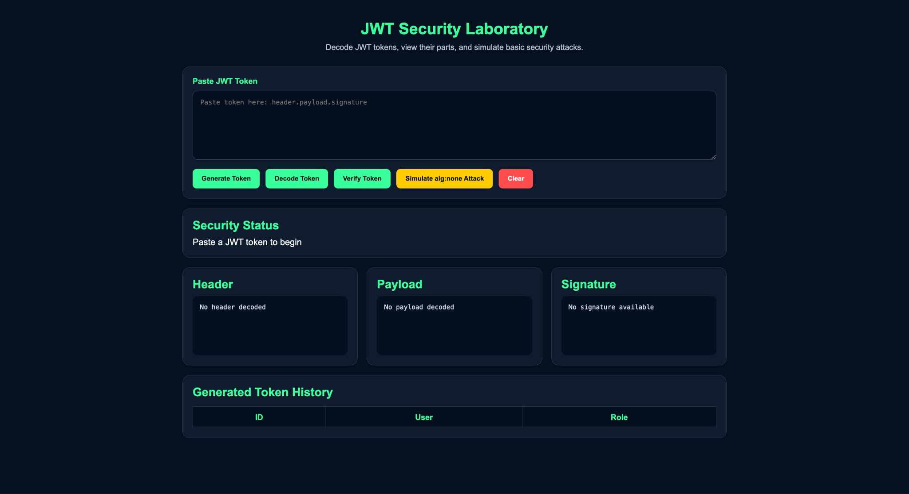
- Token Generation and Decoding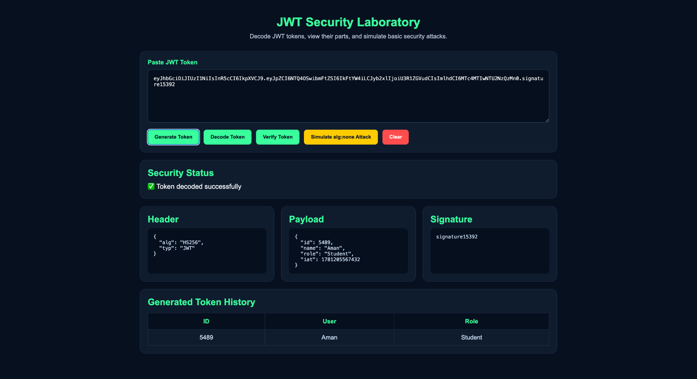
- Token Verification 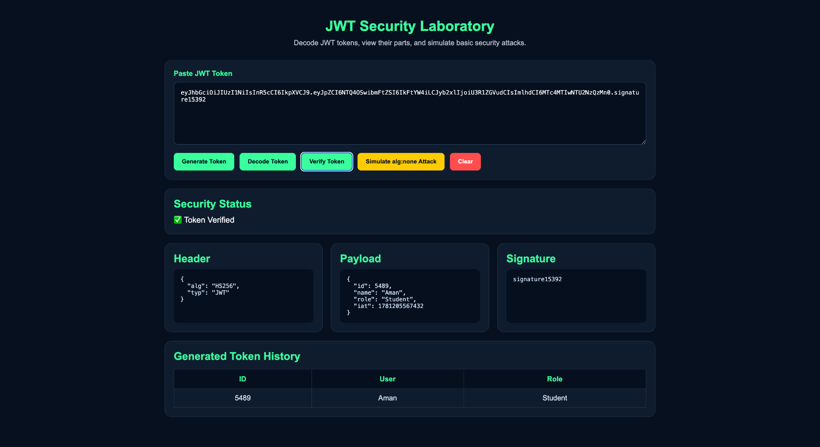
- alg:none Attack Simulation 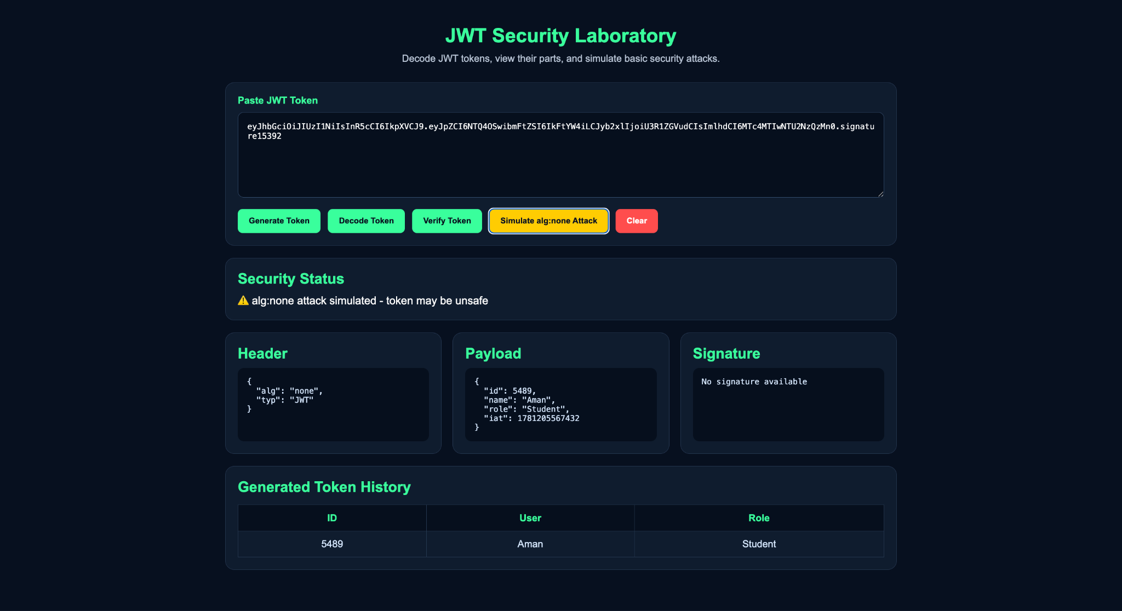

6. Case Study Results and Conclusion

Results
The JWT Security Laboratory successfully demonstrates:
- Dynamic token generation
- Token decoding
- Token verification
- Attack simulation
- Security status monitoring
- Token history management
The application provides an interactive environment for understanding JWT concepts and common security vulnerabilities.

Conclusion
This case study demonstrates the implementation of a JWT Security Laboratory using React.js. The project successfully integrates token generation, decoding, verification, attack simulation, and history tracking into a single interactive application.
The system provides users with practical knowledge of JWT architecture and highlights the importance of secure token validation techniques in modern web applications.

7. References
- React.js Official Documentation
- JWT Official Documentation (jwt.io)
- Vite Documentation
- GitHub Documentation
- Vercel Documentation
- JavaScript MDN Documentation

